System and Software Architecture Description (SSAD)

MedFRS Device Diagnostic Software

Team 16

Anfal Abdul Jaleel : System Architect

Misha Dowd : Project Manager

Delnaz Gundevia : Life Cycle Planner

Nanda Kishore Kollaje Rao : System Requirements Engineer

Anupam Kumar : Feasibility Analyst

Jackie Cheng : IIV & V

Image21.png

USC-CSSE

Table of Contents

Introduction 3

Purpose 3

Status 3

System Analysis 4

System Analysis Overview 4

System Context Diagram 4

Artifacts and Information Diagram 5

Behavior 6

Image7.png Add/choose disaster 7

Image7.png Update Victim Transportation 8

Image7.png Resend One Time Pass Email 9

Image7.png Add EMT building Assignment in Emergency 10

Image7.png Record Victim Transportation 11

Image7.png Track victims 12

Image7.png Retrieve and update Victim Data 13

Image7.png Enter Victim Data 14

Image7.png Manage Victim, Emergency EMT Assignment Information 16

Image7.png Manage Buildings/Hubs/disasters in the database 18

Image7.png Add buildings/hubs to the database 20

Image7.png Manage Individuals in the database 21

Image7.png One Time Login to MedFRS Device App 22

Image7.png Add Individuals to the list of allowed users 24

Image7.png Add Volunteers to the System 25

Image7.png Login to MedFRS Website 26

Modes of Operation 27

Technology Independent Model 28

Hardware Component Class Diagram 28

Software Component Class Diagram 29

Deployment Diagram 30

Design Class Diagram 31

Web User Login Sequence Diagram 31

Volunteer Initial Login Diagram 32

Architecture Styles, Patterns and Frameworks 33

Table of Figures

System Context Diagram **Error! Bookmark not defined.**

Artifacts and Information Diagram **Error! Bookmark not defined.**

Behavior **Error! Bookmark not defined.**

Hardware Component Class Diagram **Error! Bookmark not defined.**

Software Component Class Diagram **Error! Bookmark not defined.**

Deployment Diagram **Error! Bookmark not defined.**

Design Class Diagram **Error! Bookmark not defined.**

Web User Login Sequence Diagram **Error! Bookmark not defined.**

Volunteer Initial Login Diagram **Error! Bookmark not defined.**

# Introduction

## Purpose

This document provides in detail the structure of the proposed MedFRS Project.

## Status

The status of the SSAD is currently at the Draft Transition Readiness Review version number 3.0. In this version we have corrected mistakes present in previous versions and also modified it to reflect changed requirements.

# System Analysis

## System Analysis Overview

The primary purpose of the MedFRS system is to save more lives by introducing the secure propagation of information during emergency situations. It allows authorized volunteers to record the data of victims they categorize and transmits and collates this information so that it can be used by the Supervisors to guide the EMTs and inform them of what to expect, thus saving critical time during the emergency response. The system generates lists of victim information and location.

### System Context Diagram

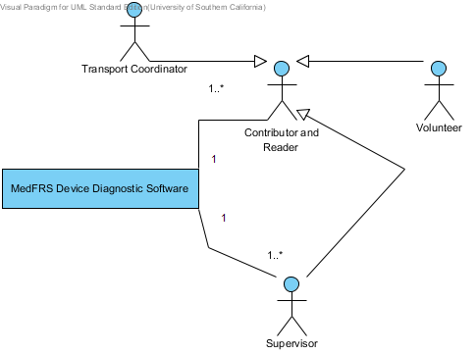

### Artifacts and Information Diagram

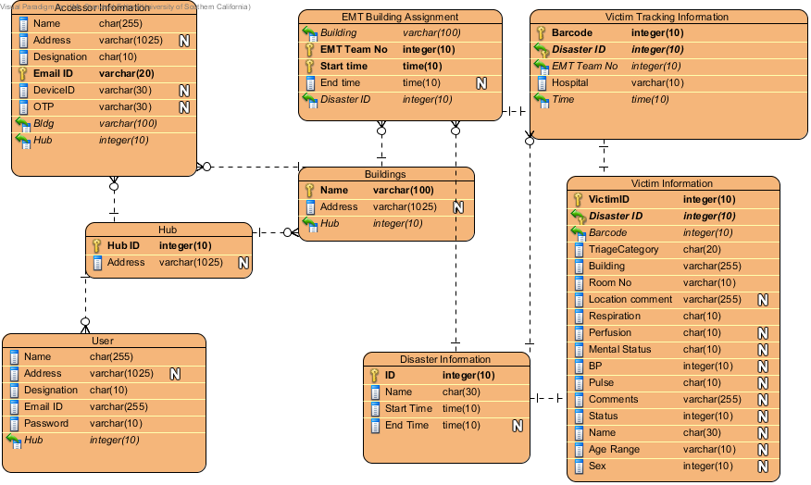

### Behavior

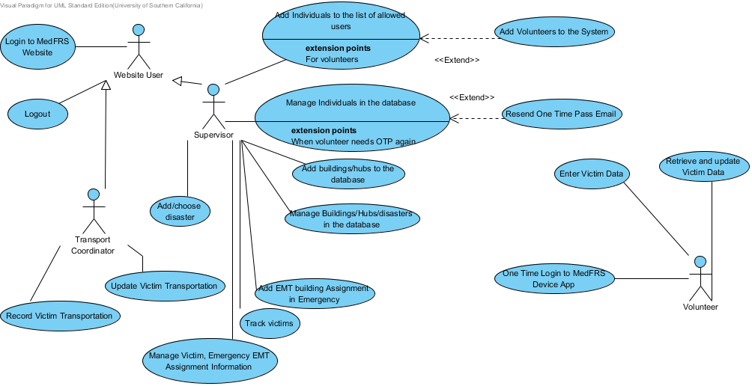

#### Use Case Descriptions

|  |  |
| --- | --- |
| Main | |
| **Preconditions** | User is logged into the system |
| **Post-conditions** | User is logged out of the system |
| **Flow of Events** | |  |  |  | | --- | --- | --- | |  | Actor Input | System Response | | 1 | Website user clicks "Log out" button |  | | 2 |  | System logs user out and redirects him to MedFRS homepage | |

### Image7.png Add/choose disaster

#### Use Case Descriptions

|  |  |
| --- | --- |
| Main | |
| **Preconditions** | Supervisor has logged in at the beginning of a disaster |
| **Post-conditions** | Disaster is added to the database, if no validations fail when needed. The Supervisor gets information only of the chosen/added disaster's. |
| **Typical Course of Action - 1** | |  |  |  | | --- | --- | --- | |  | Actor Input | System Response | | 1 | Supervisor clicks "Emergency" button |  | | 2 |  | System redirects to Disaster Page | | 3 | Supervisor chooses Add Disaster and fills disaster details |  | | 4 | Supervisor clicks "Enter" |  | | 5 |  | System validates that all fields are non-empty | | 6 |  | System inserts the disaster record in the database | | 7 |  | System redirects to Supervisor's Emergency Disaster Homepage | |
| **Typical Course of Action - 2** | |  |  |  | | --- | --- | --- | |  | Actor Input | System Response | | 1 | Supervisor clicks "Emergency" button |  | | 2 |  | System redirects to Disaster Page | | 3 | Supervisor chooses Select Disaster and picks an open disaster |  | | 4 |  | System redirects to Supervisor's Emergency Disaster Homepage | |
| **Exceptional Course of Action** | |  |  |  | | --- | --- | --- | |  | Actor Input | System Response | | 1 | Supervisor clicks "Emergency" button |  | | 2 |  | System redirects to Disaster Page | | 3 | Supervisor chooses Add Disaster and fills disaster details |  | | 4 | Supervisor clicks "Enter" |  | | 5 |  | System validates that all fields are non-empty | | 6 |  | System redirects to submitted Disaster Page | |

### Image7.png Update Victim Transportation

#### Use Case Descriptions

|  |  |
| --- | --- |
| Main | |
| **Preconditions** | Transport Coordinator has entered victim tracking in the database, and wants to change an entry |
| **Post-conditions** | Information has been updated in the database if no validations fail. |
| **Typical Course of Action** | |  |  |  | | --- | --- | --- | |  | Actor Input | System Response | | 1 | Transport Coordinator clicks "Update" button next to the entry |  | | 2 |  | Redirects to the Update Victim Tracking Form Page | | 3 | Transport Coordinator enters updated data |  | | 4 | Transport Coordinator clicks "Submit Form" button |  | | 5 |  | System validates input (all fields are filled out) | | 6 |  | System updates victim tracking record in the database | | 7 |  | Redirects to the Transport Coordinator page | |
| **Exceptional Course of Action** | |  |  |  | | --- | --- | --- | |  | Actor Input | System Response | | 1 | Transport Coordinator clicks "Update" button next to the entry |  | | 2 |  | Redirects to the Update Victim Tracking Form Page | | 3 | Transport Coordinator enters updated data |  | | 4 | Transport Coordinator clicks "Submit Form" button |  | | 5 |  | System validates input (all fields are filled out) | | 6 |  | Redirects to the submitted Update Victim Tracking Form Page | |

### Image7.png Resend One Time Pass Email

#### Use Case Descriptions

|  |  |
| --- | --- |
| Main | |
| **Preconditions** | Volunteer has already been added to the database but his device has not been registered or he has changed his device. Supervisor has logged in and clicked non-emergency |
| **Post-conditions** | The device ID is cleared and the OTP sent to the volunteer |
| **Typical Course of Action** | |  |  |  | | --- | --- | --- | |  | Actor Input | System Response | | 1 | Supervisor clicks "Manage individuals" button |  | | 2 |  | Redirects to the Manage Individuals Page with list of individual details | | 3 | Supervisor clicks "Resend OTP" button next to Volunteer's data |  | | 4 |  | Redirects to the Individual Resend OTP Page | | 5 | Supervisor clicks "Resend OTP" button |  | | 6 |  | System clears device ID of the Volunteer in the database | | 7 |  | System sends OTP to volunteer's email ID | | 8 |  | Redirects to the Manage Individuals page | |
| **Exceptional Course of Action** | |  |  |  | | --- | --- | --- | |  | Actor Input | System Response | | 1 | Supervisor clicks "Manage individuals" button |  | | 2 |  | Redirects to the Manage Individuals Page with list of individual details | | 3 | Supervisor clicks "Resend OTP" button next to Volunteer's data |  | | 4 |  | Redirects to the Individual Resend OTP Page | | 5 | Supervisor clicks "Return" button |  | | 6 |  | Redirects to the Manage Individuals page | |

### Image7.png Add EMT building Assignment in Emergency

#### Use Case Descriptions

|  |  |
| --- | --- |
| Main | |
| **Preconditions** | Buildings have been added to the database, an EMT team is assigned a building to focus on. Supervisor has logged into the system and is in the Emergency section. |
| **Post-conditions** | EMT get a printed list of victims in the building and the EMT building assignment is recorded in the database if no validations fail. |
| **Typical Course of Action** | |  |  |  | | --- | --- | --- | |  | Actor Input | System Response | | 1 | Supervisor clicks "Add EMT Assignment" button |  | | 2 |  | Redirects to the Building Assignments Page with a list of buildings, with their number of injured, number of critically injured, Volunteer Assignments, and EMT assignments. | | 3 | Supervisor clicks "Add EMT" button next to the building's details |  | | 4 |  | System returns Add EMT Form page | | 5 | Supervisor enters EMT team number |  | | 6 | Supervisor clicks "Enter" button |  | | 7 |  | System validates input (EMT team number field is filled out) | | 8 |  | System inserts the new assignment record in the database | | 9 |  | System prints out the list of victims in the assigned building sorted by triage category | | 10 |  | Redirects to the Supervisor's Emergency Homepage | |
| **Exceptional Course of Action** | |  |  |  | | --- | --- | --- | |  | Actor Input | System Response | | 1 | Supervisor clicks "Add EMT Assignment" button |  | | 2 |  | Redirects to the Building Assignments Page with a list of buildings, with their number of injured, number of critically injured, and EMT assignments. | | 3 | Supervisor clicks "Add EMT" button next to the building's details |  | | 4 |  | System returns Add EMT Form page | | 5 | Supervisor enters EMT team number |  | | 6 | Supervisor clicks "Enter" button |  | | 7 |  | System validates input (EMT team number field is filled out) | | 8 |  | Redirects to the submitted Add EMT Form page | |

### Image7.png Record Victim Transportation

#### Use Case Descriptions

|  |  |
| --- | --- |
| Main | |
| **Preconditions** | Tagged Victim has been brought to the hub by the EMT and is to be taken to a hospital by an ambulance and Transport Coordinator is logged onto the website, |
| **Post-conditions** | Victim destination and transport is entered into the database and the associated EMT team is unassigned from their building if no validations fail. |
| **Typical Course of Action** | |  |  |  | | --- | --- | --- | |  | Actor Input | System Response | | 1 | Transport Coordinator enters the Victim's barcode, Ambulance number and destination hospital |  | | 2 | Transport Coordinator clicks "Enter" button |  | | 3 |  | Check that barcode, ambulance number and destination hospital entered are non-empty | | 4 |  | Inserts record into the database | | 5 |  | Updates the database that the Ambulance is unassigned from their building (deletes the record) | | 6 |  | Redirects to the Transport coordinator's Homepage | |
| **Exceptional Course of Action** | |  |  |  | | --- | --- | --- | |  | Actor Input | System Response | | 1 | Transport Coordinator enters the Victim's barcode, Ambulance number and destination hospital |  | | 2 | Transport Coordinator clicks "Enter" button |  | | 3 |  | Check that barcode, ambulance number and destination hospital entered are non-empty | | 4 |  | Displays error and Redirects to the Transport coordinator's Homepage | |

### Image7.png Track victims

#### Use Case Descriptions

|  |  |
| --- | --- |
| Main | |
| **Preconditions** | Victims have been added to the database |
| **Post-conditions** | Supervisor views a list or a of all/subset of the victims' details and their locations |
| **Typical Course of Action** | |  |  |  | | --- | --- | --- | |  | Actor Input | System Response | | 1 | Supervisor clicks "Track victims" button |  | | 2 |  | Redirects to the Victim Information Page with list of Victim details | | 3 | Supervisor clicks "Search" button |  | | 4 |  | Redirects to the Find Victim Form Page | | 5 | Supervisor enters data to be looked for in each field |  | | 6 | Supervisor clicks "Search" button |  | | 7 |  | System validates input as being correct (at least one field is filled out) | | 8 |  | System queries database | | 9 |  | Returns Search Result page | |

### Image7.png Retrieve and update Victim Data

#### Use Case Descriptions

|  |  |
| --- | --- |
| Main | |
| **Preconditions** | Victim has already been adden to the database and tagged |
| **Post-conditions** | Volunteer sees the victim's information and the victims information has been updated in the database if no validations fail. |
| **Typical Course of Action** | |  |  |  | | --- | --- | --- | |  | Actor Input | System Response | | 1 | Volunteer clicks "Retrieve Victim" button |  | | 2 |  | Redirects to the Victim Search Page | | 3 | Volunteer enters Victims Barcode |  | | 4 |  | System searches for victim and Redirects to the Victim's Update Page | | 5 | Volunteer updates information |  | | 6 | Volunteer presses next |  | | 7 |  | System validates input(at least Barcode and Location fields are filled out) | | 8 |  | System updates victim record in the database | | 9 |  | System redirects to Volunteer Homepage | |
| **Exceptional Course of Action** | |  |  |  | | --- | --- | --- | |  | Actor Input | System Response | | 1 | Volunteer clicks "Retrieve Victim" button |  | | 2 |  | Redirects to the Victim Search Page | | 3 | Volunteer enters Victims Barcode |  | | 4 |  | System searches for victim and Redirects to the Victim's Update Page | | 5 | Volunteer updates information |  | | 6 | Volunteer presses next |  | | 7 |  | System validates input(at least Barcode and Location fields are filled out) | | 8 |  | System displays error message and redirects to Entered victims Category's Page | |

### Image7.png Enter Victim Data

#### Use Case Descriptions

|  |  |
| --- | --- |
| Main | |
| **Preconditions** | Volunteer has logged into his device and victim has not already been tagged |
| **Post-conditions** | Victim information is added to the database if no validations fail. |
| **Typical Course of Action - 1** | |  |  |  | | --- | --- | --- | |  | Actor Input | System Response | | 1 | Volunteer clicks "Add Victim" button |  | | 2 |  | Redirects to the Is He Breathing Page | | 3 | Volunteer enters Yes |  | | 4 |  | Redirects to the Respiration/ Perfusion/ Mental Status Page | | 5 | Volunteer enters Yes/No for all questions |  | | 6 |  | System categorizes the victim and redirects to that Category's Page | | 7 | Volunteer enters Barcode and Location Information |  | | 8 | Volunteer presses next |  | | 9 |  | System redirects to Vitals and Comments Page | | 10 | Volunteer enters vitals and comments |  | | 11 | Volunteer presses next |  | | 12 |  | System validates input(at least Barcode and Location fields are filled out) | | 13 |  | System adds a new victim record to the database | | 14 |  | System redirects to Volunteer Homepage | |
| **Typical Course of Action - 2** | |  |  |  | | --- | --- | --- | |  | Actor Input | System Response | | 1 | Volunteer clicks "Add Victim" button |  | | 2 |  | Redirects to the Is He Breathing Page | | 3 | Volunteer enters No |  | | 4 |  | System categorizes the victim and redirects to that Category's Page | | 5 | Volunteer enters Barcode and Location Information |  | | 6 | Volunteer presses next |  | | 7 |  | System redirects to Vitals and Comments Page | | 8 | Volunteer enters vitals and comments |  | | 9 | Volunteer presses next |  | | 10 |  | System validates input(at least Barcode and Location fields are filled out) | | 11 |  | System adds a new victim record to the database | | 12 |  | System redirects to Volunteer Disaster Homepage | |
| **Exceptional Course of Action** | |  |  |  | | --- | --- | --- | |  | Actor Input | System Response | | 1 | Volunteer clicks "Add Victim" button |  | | 2 |  | Redirects to the Is He Breathing Page | | 3 | Volunteer enters Yes |  | | 4 |  | Redirects to the Respiration/ Perfusion/ Mental Status Page | | 5 | Volunteer enters Yes/No for all questions |  | | 6 |  | System categorizes the victim and redirects to that Category's Page | | 7 | Volunteer enters Barcode and Location Information |  | | 8 | Volunteer presses next |  | | 9 |  | System redirects to Vitals and Comments Page | | 10 | Volunteer enters vitals and comments |  | | 11 | Volunteer presses next |  | | 12 |  | System validates input(at least Barcode and Location fields are filled out) | | 13 |  | System displays error message and redirects to entered victims Category's Page | |

### Image7.png Manage Victim, Emergency EMT Assignment Information

#### Use Case Descriptions

|  |  |
| --- | --- |
| Main | |
| **Preconditions** | Database has been initialized and the emergency tables populated. |
| **Post-conditions** | Information in the database is updated if no validations fail. |
| **Typical Course of Action - 1** | |  |  |  | | --- | --- | --- | |  | Actor Input | System Response | | 1 | Supervisor clicks "Manage victims/EMT assignments" button |  | | 2 |  | Redirects to the Manage Victims/EMT Assignments Page with list of Victim/EMT Assignment details | | 3 | Supervisor clicks "Update" button next to Victim's/EMT Assignment's data |  | | 4 |  | Redirects to the Update Victims/EMT Assignments Form Page | | 5 | Supervisor enters updated data |  | | 6 | Supervisor clicks "Submit Form" button |  | | 7 |  | System validates input as being correct (at least the non-null constrained fields are filled out) | | 8 |  | System updates record in the database | | 9 |  | Redirects to the Manage Victims/EMT Assignments page | |
| **Typical Course of Action - 2** | |  |  |  | | --- | --- | --- | |  | Actor Input | System Response | | 1 | Supervisor clicks "Manage Victims/EMT Assignments" button |  | | 2 |  | Redirects to the Manage Victims/EMT Assignments Page with list of Victim/EMT Assignment details | | 3 | Supervisor clicks "Delete" button next to Victim's/EMT Assignment's data |  | | 4 |  | Redirects to the Victim's/EMT Assignment's Delete Page | | 5 | Supervisor clicks "Delete" button |  | | 6 |  | System deletes Victim's/EMT Assignment's from the database | | 7 |  | Redirects to the Manage Victims/EMT Assignments page | |
| **Exceptional Course of Action** | |  |  |  | | --- | --- | --- | |  | Actor Input | System Response | | 1 | Supervisor clicks "Manage Victims/EMT Assignments" button |  | | 2 |  | Redirects to the Manage Victims/EMT Assignments Page with list of Victim/EMT Assignment details | | 3 | Supervisor clicks "Update" button next to Victim's/EMT Assignment's data |  | | 4 |  | Redirects to the Update Victims/EMT Assignments Form Page | | 5 | Supervisor enters updated data |  | | 6 | Supervisor clicks "Submit Form" button |  | | 7 |  | System validates input as being correct (at least the non-null constrained fields are filled out) | | 8 |  | Redirects to the submitted Update Form page | |

### Image7.png Manage Buildings/Hubs/disasters in the database

#### Use Case Descriptions

|  |  |
| --- | --- |
| Main | |
| **Preconditions** | Database has already been initialized, and buildings/hubs/disasters have been added to the database. Supervisor has logged in and clicked non-emergency. |
| **Post-conditions** | Information in the database has been updated if no validations fail. |
| **Typical Course of Action - 1** | |  |  |  | | --- | --- | --- | |  | Actor Input | System Response | | 1 | Supervisor clicks "Manage buildings/hubs/disasters" button |  | | 2 |  | Redirects to the Manage Buildings/hubs/disasters Page with list of details | | 3 | Supervisor clicks "Update" button next to data |  | | 4 |  | Redirects to the Update building/hub/disaster Form Page | | 5 | Supervisor enters updated data |  | | 6 | Supervisor clicks "Submit Form" button |  | | 7 |  | System validates input(at least required fields are filled out) | | 8 |  | System updates record in the database | | 9 |  | Redirects to the Manage Buildings/hubs/disasters page | |
| **Typical Course of Action - 2** | |  |  |  | | --- | --- | --- | |  | Actor Input | System Response | | 1 | Supervisor clicks "Manage buildings/hubs/disasters" button |  | | 2 |  | Redirects to the Manage Buildings/hubs/disasters Page with list of details | | 3 | Supervisor clicks "Delete" button next to data |  | | 4 |  | Redirects to the Building's/hub's/disaster's Delete Page | | 5 | Supervisor clicks "Delete" button |  | | 6 |  | System deletes record from the database | | 7 |  | Redirects to the Manage Buildings/hubs/disasters page | |
| **Exceptional Course of Action** | |  |  |  | | --- | --- | --- | |  | Actor Input | System Response | | 1 | Supervisor clicks "Manage buildings/hubs/disasters" button |  | | 2 |  | Redirects to the Manage Buildings/hubs/disasters Page with list of building details | | 3 | Supervisor clicks "Update" button next to data |  | | 4 |  | Redirects to the Update building/hub/disaster Form Page | | 5 | Supervisor enters updated data |  | | 6 | Supervisor clicks "Submit Form" button |  | | 7 |  | System validates input(at least required fields are filled out) | | 8 |  | Redirects to the submitted Update Form page | |

### Image7.png Add buildings/hubs to the database

#### Use Case Descriptions

|  |  |
| --- | --- |
| Main | |
| **Preconditions** | Database has been initialized and the building/hub/disaster is not in the database. Supervisor has logged in and clicked non-emergency |
| **Post-conditions** | Building is added to the database if no validations fail. |
| **Typical Course of Action** | |  |  |  | | --- | --- | --- | |  | Actor Input | System Response | | 1 | Supervisor clicks "Add building/hub" button |  | | 2 |  | Redirects to the Add Building/hub Form Page | | 3 | Supervisor enters Building/hub details |  | | 4 | Supervisor clicks "Submit Form" button |  | | 5 |  | System validates input(at least required fields are filled out) | | 6 |  | System inserts the new record in the database | | 7 |  | Redirects to the View Building's/hub's page | |
| **Exceptional Course of Action** | |  |  |  | | --- | --- | --- | |  | Actor Input | System Response | | 1 | Supervisor clicks "Add building/hub" button |  | | 2 |  | Redirects to the Add Building/hub Form Page | | 3 | Supervisor enters Building/hub details |  | | 4 | Supervisor clicks "Submit Form" button |  | | 5 |  | System validates input(at least required fields are filled out) | | 6 |  | System displays error and redirects to the submitted Add Building/hub Form Page | |

### Image7.png Manage Individuals in the database

#### Extension Points

|  |
| --- |
| When volunteer needs OTP again |

#### Use Case Descriptions

|  |  |
| --- | --- |
| Main | |
| **Preconditions** | Database has already been initialized, and individuals have been added to the database. Supervisor has logged in and clicked non-emergency |
| **Post-conditions** | Information in the database has been updated if no validations fail. |
| **Typical Course of Action - 1** | |  |  |  | | --- | --- | --- | |  | Actor Input | System Response | | 1 | Supervisor clicks "Manage individuals" button |  | | 2 |  | Redirects to the Manage Individuals Page with list of individual details | | 3 | Supervisor clicks "Update" button next to Individual's data |  | | 4 |  | Redirects to the Update Individual Form Page | | 5 | Supervisor enters updated data |  | | 6 | Supervisor clicks "Submit Form" button |  | | 7 |  | System validates input (at least Name and Designation fields are filled out) | | 8 |  | System updates individual's record in the database | | 9 |  | Redirects to the Manage Individuals page | |
| **Typical Course of Action - 2** | |  |  |  | | --- | --- | --- | |  | Actor Input | System Response | | 1 | Supervisor clicks "Manage individuals" button |  | | 2 |  | Redirects to the Manage Individuals Page with list of individual details | | 3 | Supervisor clicks "Delete" button next to Individual's data |  | | 4 |  | Redirects to the Individual's Delete Page | | 5 | Supervisor clicks "Delete" button |  | | 6 |  | System deletes individual's record from the database | | 7 |  | Redirects to the Manage Individuals page | |
| **Exceptional Course of Action** | |  |  |  | | --- | --- | --- | |  | Actor Input | System Response | | 1 | Supervisor clicks "Manage individuals" button |  | | 2 |  | Redirects to the Manage Individuals Page with list of individual details | | 3 | Supervisor clicks "Delete" button next to Individual's data |  | | 4 |  | Redirects to the Individual's Delete Page | | 5 | Supervisor clicks "Return" button |  | | 6 |  | Redirects to the Manage Individuals page | |

### Image7.png One Time Login to MedFRS Device App

#### Use Case Descriptions

|  |  |
| --- | --- |
| Main | |
| **Preconditions** | Volunteer has already been registered by the supervisor and has downloaded the app on his phone. He has also received his OTP |
| **Post-conditions** | Volunteer's device is registered in the system and he does not need to login to the app on this device again as long as he is in the system |
| **Typical Course of Action** | |  |  |  | | --- | --- | --- | |  | Actor Input | System Response | | 1 | Volunteer enters his OTP |  | | 2 | Volunteer clicks "Enter" |  | | 3 |  | Check that OTP entered is non-empty | | 4 |  | Authenticate the OTP | | 5 |  | System generates a unique device ID and sends it to the device | | 6 |  | The device app receives the acknowledgment and stores the device id so that every future opening of the app is aware of the verification. System redirects to Volunteer Homepage. | |
| **Exceptional Course of Action - 1** | |  |  |  | | --- | --- | --- | |  | Actor Input | System Response | | 1 | Volunteer enters his OTP |  | | 2 | Volunteer clicks "Enter" |  | | 3 |  | Check that OTP entered is non-empty | | 4 |  | Display error message and redirect to login page | |
| **Exceptional Course of Action - 2** | |  |  |  | | --- | --- | --- | |  | Actor Input | System Response | | 1 | Volunteer enters his OTP |  | | 2 | Volunteer clicks "Enter" |  | | 3 |  | Check that OTP entered is non-empty | | 4 |  | Authenticate the OTP | | 5 |  | Device app receives failure notice and displays error message and redirects to login page | |

### Image7.png Add Individuals to the list of allowed users

#### Extension Points

|  |
| --- |
| For volunteers |

#### Use Case Descriptions

|  |  |
| --- | --- |
| Main | |
| **Preconditions** | Individual is not in the database and has gone to the supervisor to register, supervisor has logged in and clicked non-emergency |
| **Post-conditions** | Individual is added to the database with designation if no validations fail. |
| **Typical Course of Action** | |  |  |  | | --- | --- | --- | |  | Actor Input | System Response | | 1 | Supervisor clicks "Add individual" button |  | | 2 |  | Redirects to the Add Individual Form Page | | 3 | Supervisor enters individual's personal details, designation and building/hub assignment |  | | 4 | Supervisor clicks "Submit Form" button |  | | 5 |  | System validates input (at least Name and Designation fields are filled out) | | 6 |  | System inserts the new individual's record in the database | | 7 |  | Redirects to the View Individual's page | |
| **Exceptional Course of Action** | |  |  |  | | --- | --- | --- | |  | Actor Input | System Response | | 1 | Supervisor clicks "Add individual" button |  | | 2 |  | Redirects to the Add Individual Form Page | | 3 | Supervisor enters individual's personal details, designation and building/hub assignment |  | | 4 | Supervisor clicks "Submit Form" button |  | | 5 |  | System validates input (at least Name and Designation fields are filled out) | | 6 |  | System displays error and redirects to the submitted Add Individual Form Page | |

### Image7.png Add Volunteers to the System

#### Use Case Descriptions

|  |  |
| --- | --- |
| Main | |
| **Preconditions** | Volunteer is not in the database and has gone to the supervisor to register, supervisor has logged in and clicked non-emergency |
| **Post-conditions** | Volunteer is added to the database with designation,and sent an OTP (One Time Pass) if no validations fail. |
| **Typical Course of Action** | |  |  |  | | --- | --- | --- | |  | Actor Input | System Response | | 1 | Supervisor clicks "Add individual" button |  | | 2 |  | Redirects to the Add Individual Form Page | | 3 | Supervisor enters individual's personal details, designation (Volunteer) and building assignment |  | | 4 | Supervisor clicks "Submit Form" button |  | | 5 |  | System validates input as being correct (at least Name and Designation fields are filled out) | | 6 |  | System inserts the new individual's record in the database | | 7 |  | System generates a One Time Pass (OTP) and sends it to the volunteers email id and then redirects to the View Individual's page | |
| **Exceptional Course of Action** | |  |  |  | | --- | --- | --- | |  | Actor Input | System Response | | 1 | Supervisor clicks "Add individual" button |  | | 2 |  | Redirects to the Add Individual Form Page | | 3 | Supervisor enters individual's personal details, designation and building/hub assignment |  | | 4 | Supervisor clicks "Submit Form" button |  | | 5 |  | System validates input (at least Name and Designation fields are filled out) | | 6 |  | System displays error and redirects to the submitted Add Individual Form Page | |

### Image7.png Login to MedFRS Website

#### Use Case Descriptions

|  |  |
| --- | --- |
| Main | |
| **Preconditions** | The system and databases have been populated. |
| **Post-conditions** | Supervisor and Transport Coordinator with valid username and password are logged into the system while all others see an error message and are redirected to the login page |
| **Typical Course of Action** | |  |  |  | | --- | --- | --- | |  | Actor Input | System Response | | 1 | Website User enters his username and password in the Login page |  | | 2 | Website User clicks "Log In" button |  | | 3 |  | Check that username and password entered are non-empty | | 4 |  | Authenticate the username and password | | 5 |  | Redirect to MedFRS Supervisor/Transport Coordinator Homepage | |
| **Exceptional Course of Action - 1** | |  |  |  | | --- | --- | --- | |  | Actor Input | System Response | | 1 | Person enters username and password in the Login page |  | | 2 | Person clicks "Log In" button |  | | 3 |  | Check that username and password entered are non-empty | | 4 |  | Authenticate the username and password | | 5 |  | Display error message and redirect to MedFRS Login Page | |
| **Exceptional Course of Action - 2** | |  |  |  | | --- | --- | --- | |  | Actor Input | System Response | | 1 | Person enters username and password in the Login page |  | | 2 | Person clicks "Log In" button |  | | 3 |  | Check that username and password entered are non-empty | | 4 |  | Display error message and redirect to MedFRS Login Page | |

### Modes of Operation

The system has two modes

* Nonemergency : The supervisors performs overviewing and maintenance tasks on the website, eg. – adding individuals to the authorized list, updating information in the system,etc.
* Emergency : The volunteer adds information to the system, which is overseen and dispersed by the supervisors to help the EMTs. The transport coordinator also adds information of the victims’ transportation to help locate them (track) later.

# Technology Independent Model

## Hardware Component Class Diagram

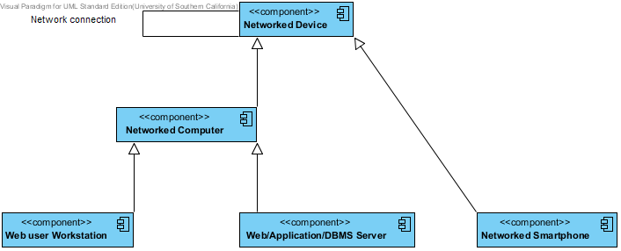

## Software Component Class Diagram

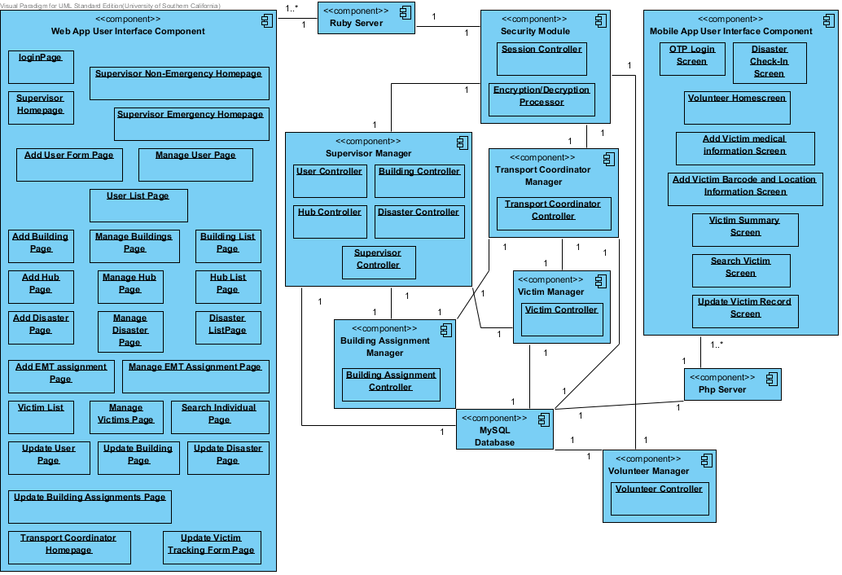

## Deployment Diagram

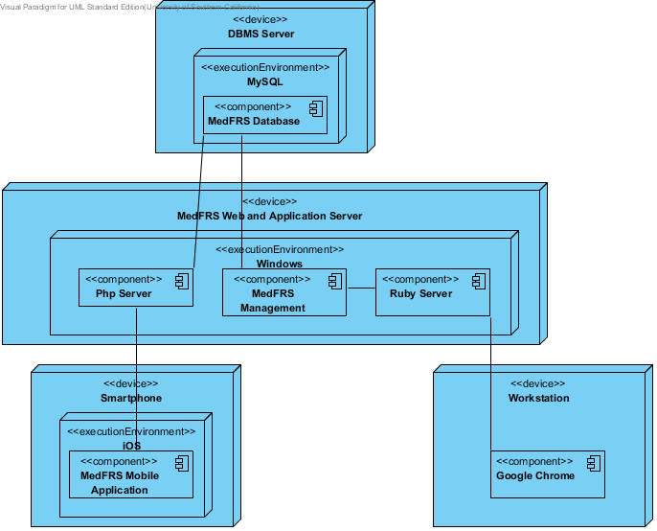

## Design Class Diagram

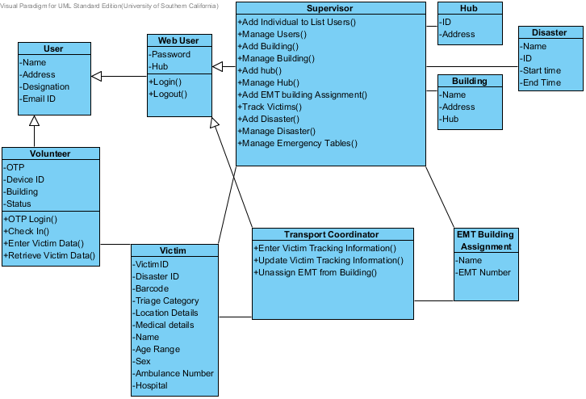

## Web User Login Sequence Diagram

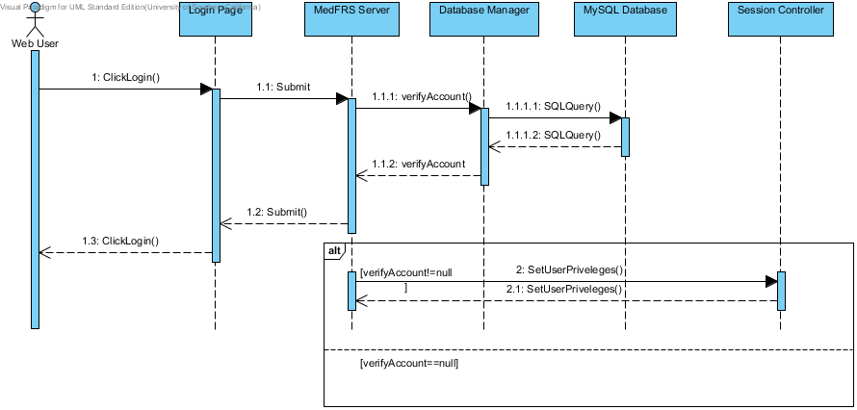

## Volunteer Initial Login Diagram

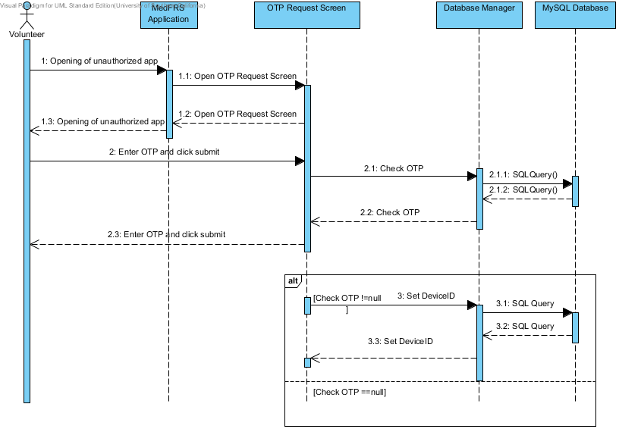

# Architecture Styles, Patterns and Frameworks

|  |  |  |
| --- | --- | --- |
| **Name** | **Description** | **Benefits, Costs, and Limitations** |
| MVC | Pattern which separates the representation of information from the user's interaction with it. | Better flow while writing code due to the compartmentalization |